Bluetooth Mesh Hands-On Training Lab

KEY FEATURES

Using Apple Home app to pair with HomeKit accessory

Using Siri to control the HomeKit accessory

This training lab shows how to flash the EFR32 with a HomeKit demo firmware and setup code file, then pair and control the device from your phone using Apple’s Home app or Siri. You will need the following items installed for this training:

* [Simplicity Studio v4](http://www.silabs.com/products/mcu/Pages/simplicity-studio.aspx) (If already installed then make sure it is updated)
* iOS device compatible with HomeKit (a list can be found in AN1037 chapter 4)
* ThunderBoard Sense

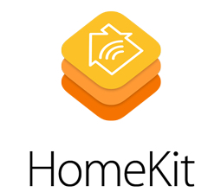

# Flashing the *.hex files

This training package contains to multiple *.hex files: soc-homekit-thunderboard-sense_X.hex (where X is a number which is different for each file) and setup_code_111_22_333.hex. The first one are the demo firmware and the second one contains the setup code required to pair the device with the home app. The reason why there are multiple firmware files is to avoid that participants connect to each other’s boards. The number on each file is also on the device name “HomeKit Accessory X” so each participant will be attributed one number and that is the file that he/she should use for this training.

To flash the *.hex files do the following steps:

1. Open Simplicity Studio and plug Thunderboard Sense into your PC via the USB cable
2. Open the Tools menu (1) and select the Flash Programmer (2)

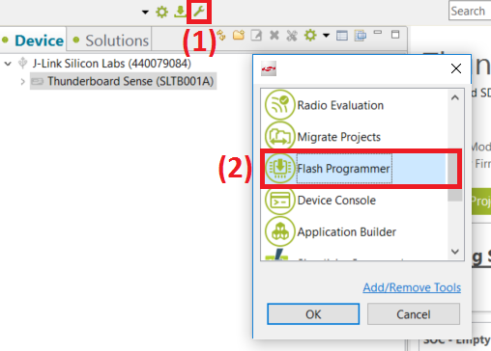

1. Start by erasing the device (1), then browse to the soc-homekit-thunderboard-sense_X.hex (2) and program it into the WSTK (3) (remember to use the file with the correct number). Repeat (2) and (3) but now selecting the setup_code_111_22_333.hex file **(do not erase in between flashing the 2 files).** Once both files are flashed press the reset button on the lower-right of the WSTK.

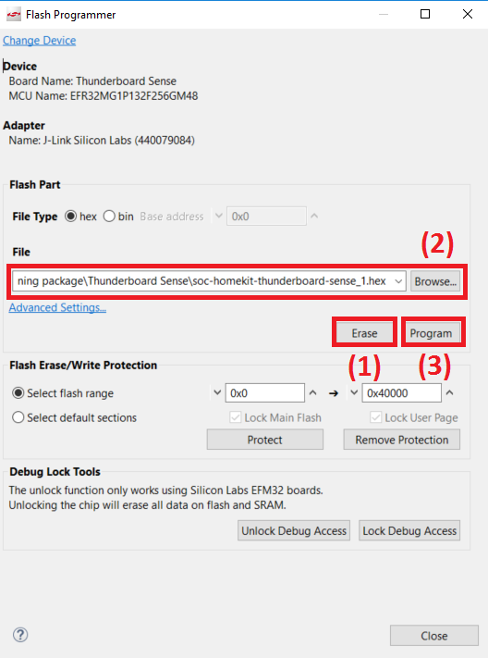

# Testing the project

**Note:** Before testing the demo it is recommended that you power-cycle your iOS device to avoid any GATT caching issues.

The next flow-chart shows how to pair with the HomeKit accessory that you just created.

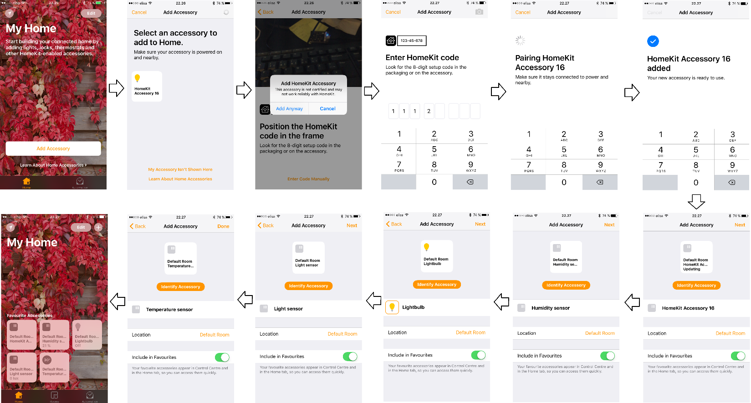

1. Open the Home App and select “Add Accessory”
2. Select the HomeKit Accessory that is discovered by the Home App (you should select the one with the number from your *.hex file)
3. You will see a warning that the accessory is not certified, select “Add Anyway”. This is because the demo has developer mode enabled so that it can be used without the authentication chip.
4. Select “Enter Code Manually” and enter the setup code 111-22-333
5. The HomeKit Accessory will be added to the app. Select “Next” as the several accessories are discovered.

You will then see multiple accessories displayed on the Home App. If you press the Lightbulb you will be able to turn the RGB LEDs on Thunderboard Sense ON and OFF. The sensors on Thunderboard feed the data for the accessories that you see on the Home app.

You can now also control the accessories through Siri as it also has HomeKit integration. If you say “Turn lights ON” or “Turn lights OFF” Siri will act on the LED according to your command.

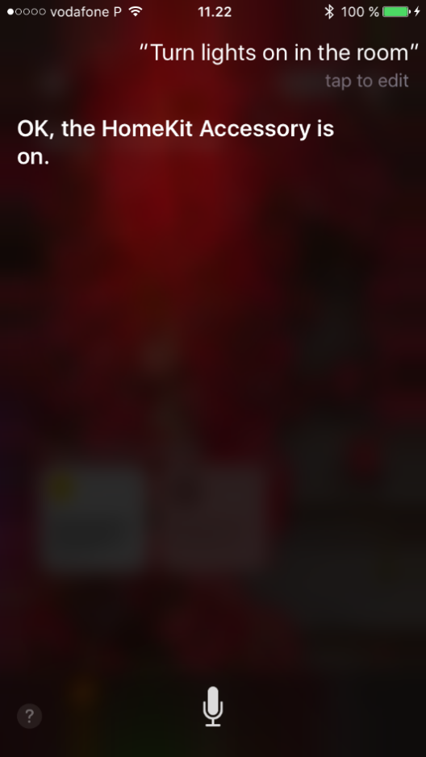

To read the temperature you can ask “What is the temperature in the room?”.

